Social networks : all bad ?
- Social media analysis
- Check the news !
- Cartoons on social networks

Compétences travaillées :
D.3.3.2 Utiliser les médias et l’information de manière responsable et raisonnée
D.2.3.2 Apprécier la fiabilité des informations recueillies

- Social media analysis
  - Answer the online survey ! (and wait for the results…)
https://forms.gle/EEfpc7R5Pot6BbBV6
  - Answer the following questions :
Marine Le Pen posted this picture and deleted it from her FB account a few hours later. Why ?
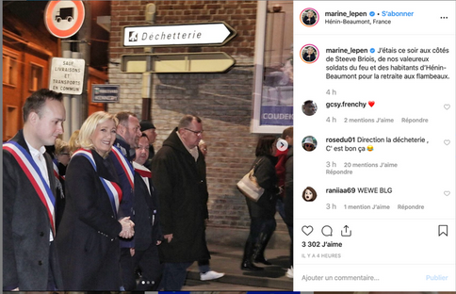

This man got fired after this photo was posted on FB. Why ?
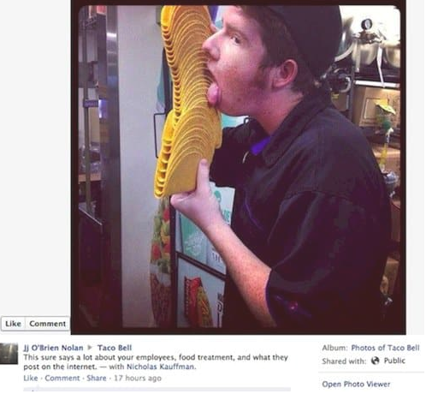

Read the following papers and answer the questions :
Cameron Reilly Scot guard
http://edition.cnn.com/2011/WORLD/europe/04/25/uk.royal.wedding.guard/index.html
It’s not all bad : the social Good of social media.
https://www.forbes.com/sites/ajagrawal/2016/03/18/its-not-all-bad-the-social-good-of-social-media/#63f024b756fb
- Why was Cameron Reilly fired ?
- Give an example of an account you follow or would like to follow that shows « the good of social media ».
  - Conclusions :
- What do people think about social media
- What is it mainly used for ? And why ?
- Pros and cons ?

- Fact-checking
Are the following news real or fake ?

  - Austrian teenager sues her parents for « violating privacy » with childhood Facebook pictures.

  - You can get leptospirosis from soft drink cans.

  - Albert Einstein said « Everybody is a genius but if you judge a fish by its ability to climb a tree, it will live its whole life believing that it is stupid. »

  - There was a man dressed in Muslim garb walking in a Notre-Dame tower during the fire on April 15.
For each statement, you must give a few reasons why you think it is real or fake news…
2.5 Write a list of tips to help people check the news…

- Cartoons
Look at the twelve cartoons.
Discuss with your group which one shows the main problem with social networks ?
According to you, which one is really wrong about social media ?

